  

ON

“HILL STATION LANDING PAGE" SUBMITTED TO

TELANGANA UNIVERSITY, DICHPALLY, NIZAMBAD

In partial fulfilment of the requirement for the award of the Post Graduate Degree of

MASTER OF COMPUTER APPLICATIONS



BY

**MOHAMMED ABDUL KAMRAN**

**(5174-23-862-120)**

SA

SS

**SAGARIKA MAM**



DEPARTMENT OF





2024-2025



We are grateful and would like to thank **P Prasad, Head of the**

**Department, Computer Science, Nishitha Degree College, Nizamabad** for providing us the facilities and resources required for the successful completion of our project. I also thank him/her for valuable suggestions at the time of seminar and also for his/her unique way of inspiring students through clarity of thought, enthusiasm and care. his/her constant encouragement and assistance were very helpful and made our effort a success.

I would also like to thank faculty and supporting staff of Computer Science Department and all other departments for their kind co-operation directly or indirectly in making the technical seminar a successful one.

I am also grateful to **Dr.K.Swapna,** Principal for providing me with facilities and resource required for the successful completion of my technical seminar.

I also thank him/her for his/her valuable suggestions at the time of seminars encouraged me to give my best in seminar.

And finally, I also take this opportunity to thank each and everybody who has helped directly or indirectly during the course of this

**DECLARATION**

I, hereby declare that the project thesis titled has been carried out entries guidence on

##### " HILL STATION LANDING PAGE

In the presence of P. Prasad, Head of the Computer Science

##### NISHITHA DEGREE COLLEGE, NIZAMABAD

Affiliated to Telangana University, Dichpally, Nizamabad for the partial fulfilment of the requirement for the award of master of computer applications.

##### SUBMITTED BY,

MOHAMMED ABDUL KAMRAN . 5174-23-862-120

## ABSTRACT

This mini project explores the charm and appeal of hill stations, which are beautiful mountain destinations offering a peaceful escape from city life. Hill stations are known for their cool climate, scenic views, lush greenery, and a variety of outdoor activities. This project focuses on highlighting some popular hill stations, their main attractions, and the experiences they offer. It also covers the benefits of visiting these destinations, such as relaxation, adventure, and exposure to unique local cultures. The goal is to provide a simple, easy-to-understand overview of why hill stations are a favorite getaway for nature lovers and travelers.

**Table of Contents**

|  |  |  |
| --- | --- | --- |
| **S.no** | **Title** | **Page No** |
| 1 | Aim | 01 |
| 2 | Introduction | 02 |
| 3 | System Design | 03 |
| 4 | Sample Code | 04-26 |
| 5 | Output Screens | 27-30 |
| 6 | Conclusion | 31 |
| 7 | References | 32 |

# AIM

The aim of this mini project on hill stations is to provide an in-depth exploration of these scenic mountain destinations, which are widely regarded as ideal getaways from the hustle and bustle of city life. Hill stations, known for their cool climates, lush greenery, and breathtaking views, offer a peaceful retreat for nature lovers and adventure enthusiasts alike. This project aims to highlight the unique features of hill stations, focusing on popular destinations such as Shimla, Manali, Nainital, and Darjeeling, among others.

The project seeks to explore the various attractions and activities that make hill stations so appealing. These include sightseeing spots, historical landmarks, outdoor adventures like trekking and paragliding, and peaceful lakeside experiences. By examining the natural beauty, cultural richness, and outdoor opportunities, the project aims to showcase the diverse experiences that these locations offer to visitors.

Overall, the goal of the project is to raise awareness about the significance of hill stations, both as tourist destinations and as places that provide rejuvenation, adventure, and cultural exploration, making them essential parts of the travel landscape.

## INTRODUCTION

A hill station is a serene and picturesque destination situated in the mountains, offering a refreshing escape from the busy life of cities. These high-altitude locations are known for their cool climate, lush landscapes, and scenic beauty, making them perfect retreats for those seeking tranquility and a connection with nature. Hill stations typically feature panoramic views, clean air, and a peaceful atmosphere, which are major attractions for visitors from both nearby regions and distant cities.

Historically, hill stations were developed during the colonial era as summer retreats for British officials to escape the heat of the plains. Over time, these destinations have evolved into popular tourist spots, offering a blend of natural beauty and adventure. Today, they attract millions of tourists every year who seek relief from the heat, enjoy outdoor activities, and explore unique local cultures..

Apart from their stunning views and cool weather, hill stations offer a wide range of activities such as trekking, paragliding, boating, and wildlife exploration. Visitors can also experience the local culture through traditional crafts, festivals, and local cuisines. Popular hill stations in India, such as Shimla, Manali, Nainital, and Darjeeling, are renowned for their beauty and have become major hubs for both domestic and international tourism.

### SYSTEM DESIGN

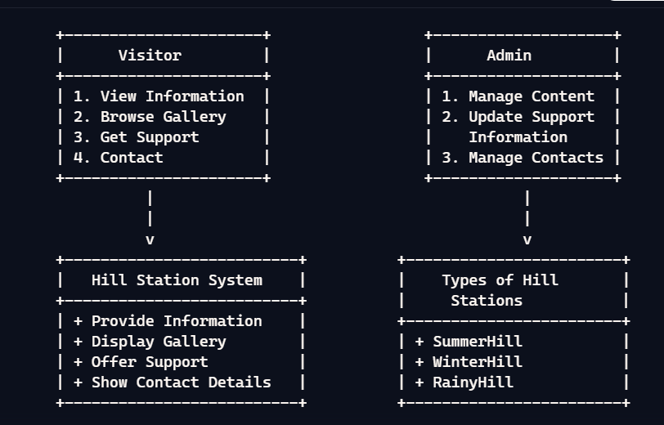

**SAMPLE CODE:**

*MAIN.HTML*

<!DOCTYPE html>

<html lang="en">

<head>

<meta charset="UTF-8">

<meta name="viewport" content="width=device-width, initial-scale=1.0">

<title>Hill Stations</title>

<link rel="stylesheet" href="styles.css">

</head>

<body>

<header>

<nav>

<div class="logo">

<img src="images/icons8-tree-48.png" alt="Hill Station Logo">

</div>

<ul class="nav-links">

<li><a href="#home">Home</a></li>

<li><a href="#types">Types</a></li>

<li><a href="#gallery">Gallery</a></li>

<li><a href="#contact">Contact</a></li>

</ul>

</nav>

</header>

<section id="home">

<div class="container">

<h1>Welcome to the Hill Stations</h1>

<p>A hill station is a town or city located at a high altitude, typically in mountainous regions, known for its cool climate and scenic beauty. Historically, hill stations were developed

during the British colonial era as summer retreats to escape the heat of the plains. </p>

</div>

</section>

<section id="types">

<div class="container">

<h2>Types of Hill Stations</h2>

<div class="types">

<div class="type">

<img src="images/summer.jpeg" alt="Summer Hill Station">

<h3>Summer Hill Stations</h3>

<p>These are popular during the summer months, offering a cool climate to escape the heat.</p>

</div>

<div class="type">

<img src="images/twos.jpg" alt="Adventure Hill Station">

<h3>Adventure Hill Stations</h3>

<p>Ideal for trekking, mountaineering, and other adventure activities.</p>

</div>

<div class="type">

<img src="images/other.jpeg" alt="Relaxation Hill Station">

<h3>Relaxation Hill Stations</h3>

<p>Perfect for those who wish to relax and unwind in peaceful surroundings.</p>

</div>

</div>

</div>

</section>

<section id="gallery">

<div class="container">

<h2>Gallery</h2>

<div class="gallery">

<img src="images/hill station.jpg" alt="Hill Station 1">

<img src="images/nature.jpg" alt="Hill Station 2">

<img src="images/relacation.jpg" alt="Hill Station 3">

<img src="images/winter.jpg" alt="Hill Station 4">

</div>

</div>

</section>

<section id="contact">

<div class="container">

<h2>Contact Us</h2>

<p>If you have any questions or need more information, feel . free to reach out!</p>

</div>

</section>

<footer>

<p>&copy; 2025 Hill Stations. All rights reserved.</p>

</footer>

</body>

</html>

*STYLES*.*CSS*

/* Reset default styles */

* {

margin: 0;

padding: 0;

box-sizing: border-box;

}

/* Body and Background */

body {

font-family: Arial, sans-serif;

line-height: 1.6;

background: url('images/bk.jpg') no-repeat center center fixed;

background-size: cover;

color: #fff;

}

/* Reset default styles */

* {

margin: 0;

padding: 0;

box-sizing: border-box;

}

/* Body Background */

body {

font-family: Arial, sans-serif;

line-height: 1.6;

background-color: #f0f0f0; /* Light background color */

}

/* Navbar Styling */

header {

background-color: rgba(0, 0, 0, 0.7); /* Dark background for navbar */

padding: 15px 20px;

position: fixed;

width: 100%;

top: 0;

left: 0;

z-index: 1000;

}

/* Flexbox Layout for Navbar */

nav {

display: flex;

justify-content: space-between; /* Space between logo and nav links */

align-items: center;

}

.logo img {

height: 50px; /* Adjust logo size */

}

/* Align the navigation links to the right */

.nav-links {

list-style: none;

display: flex;

margin-left: auto; /* Pushes nav items to the right */

}

.nav-links li {

margin-right: 20px;

}

.nav-links li a {

color: #fff;

text-decoration: none;

font-size: 18px;

}

.nav-links li a:hover {

text-decoration: underline;

}

/* Responsive Design (optional) */

@media screen and (max-width: 768px) {

.nav-links {

flex-direction: column;

align-items: center;

display: none;

width: 100%;

}

.nav-links li {

margin: 10px 0;

}

nav.active .nav-links {

display: flex;

}

}

/* Container for sections */

.container {

width: 80%;

margin: 0 auto;

}

/* Home Section */

#home {

text-align: center;

padding: 100px 0 50px;

}

#home h1 {

font-size: 3em;

}

#home p {

font-size: 1.5em;

}

/* Types Section */

#types {

padding: 50px 0;

text-align: center;

}

#types h2 {

font-size: 2.5em;

margin-bottom: 20px;

}

.types {

display: flex;

justify-content: space-between;

gap: 20px;

}

.type {

width: 30%;

background-color: rgba(0, 0, 0, 0.5);

padding: 20px;

border-radius: 10px;

text-align: center;

}

.type img {

width: 100%;

height: auto;

border-radius: 10px;

}

.type h3 {

margin-top: 15px;

font-size: 1.8em;

}

.type p {

font-size: 1em;

margin-top: 10px;

}

/* Gallery Section */

#gallery {

padding: 50px 0;

text-align: center;

}

#gallery h2 {

font-size: 2.5em;

margin-bottom: 20px;

}

.gallery {

display: flex;

justify-content: space-between;

gap: 20px;

}

.gallery img {

width: 24%;

height: auto;

border-radius: 10px;

box-shadow: 0 4px 10px rgba(0, 0, 0, 0.3);

}

.gallery img:hover {

transform: scale(1.05);

transition: transform 0.3s;

}

/* Contact Section */

#contact {

padding: 50px 0;

text-align: center;

}

#contact h2 {

font-size: 2.5em;

margin-bottom: 20px;

}

#contact p {

font-size: 1.2em;

}

/* Footer Styling */

footer {

background-color: rgba(0, 0, 0, 0.7);

color: #fff;

text-align: center;

padding: 10px 0;

position: relative;

bottom: 0;

width: 100%;

}

*NATURE.HTML*

<!DOCTYPE html>

<html lang="en">

<head>

<meta charset="UTF-8">

<meta name="viewport" content="width=device-width, initial-scale=1.0">

<title>Nature Hill Station</title>

<style>

body {

font-family: 'Arial', sans-serif;

margin: 0;

padding: 0;

background-color: #f0f4f8;

color: #333;

scroll-behavior: smooth;

}

header {

background-image: url('images/bk.jpg');

background-size: cover;

color: white;

padding: 100px 20px;

text-align: center;

position: relative;

}

header h1 {

font-size: 3em;

margin: 0;

text-shadow: 2px 2px 4px rgba(0, 0, 0, 0.7);

}

nav ul {

list-style-type: none;

padding: 0;

}

nav ul li {

display: inline;

margin: 0 15px;

}

nav ul li a {

color: white;

text-decoration: none;

font-weight: bold;

transition: color 0.3s;

}

nav ul li a:hover {

color: #ffeb3b;

}

section {

padding: 20px;

margin: 20px;

background-color: white;

border-radius: 8px;

box-shadow: 0 2px 10px rgba(0, 0, 0, 0.1);

}

.gallery-container {

display: flex;

justify-content: space-around;

flex-wrap: wrap;

}

.gallery-container img {

width: 30%;

border-radius: 8px;

margin: 10px 0;

transition: transform 0.3s, box-shadow 0.3s;

}

.gallery-container img:hover {

transform: scale(1.05);

box-shadow: 0 4px 20px rgba(0, 0, 0, 0.2);

}

footer {

text-align: center;

padding: 20px;

background-color: #4caf50;

color: white;

position: relative;

bottom: 0;

width: 100%;

}

@media (max-width: 768px) {

.gallery-container img {

width: 100%;

}

}

</style>

</head>

<body>

<header>

<h1>Welcome to Nature Hill Station</h1>

<nav>

<ul>

<li><a href="#about">About</a></li>

<li><a href="#gallery">Gallery</a></li>

<li><a href="#contact">Contact</a></li>

</ul>

</nav>

</header>

<section id="about">

<h2>About Nature Hill Station</h2>

<p>Nature Hill Station is a serene getaway nestled in the heart of lush greenery and breathtaking landscapes. It offers a perfect escape for those looking to unwind and reconnect with nature. Enjoy hiking, bird watching, and the tranquility of the great outdoors.</p>

</section>

<section id="gallery">

<h2>Gallery</h2>

<div class="gallery-container">

<img src="Adventue/a1.jpeg">

<img src="Adventue/a2.jpeg">

<img src="Adventue/a3.jpeg">

</div>

</section>

<footer id="contact">

<h2>Contact Us</h2>

<p>Email: info@naturehillstation.com</p>

<p>Phone: +123 456 7890</p>

</footer>

</body>

</html>

*SUMMER.HTML*

<!DOCTYPE html>

<html lang="en">

<head>

<meta charset="UTF-8">

<meta name="viewport" content="width=device-width, initial-scale=1.0">

<title>Summer Hill Station</title>

<style>

body {

font-family: Arial, sans-serif;

margin: 0;

padding: 0;

background-color: #f0f8ff;

}

header {

background-color: #4CAF50;

color: white;

padding: 20px;

text-align: center;

}

nav ul {

list-style-type: none;

padding: 0;

}

nav ul li {

display: inline;

margin: 0 15px;

}

nav ul li a {

color: white;

text-decoration: none;

}

section {

padding: 20px;

margin: 20px;

background-color: white;

border-radius: 8px;

box-shadow: 0 2px 10px rgba(0, 0, 0, 0.1);

}

.gallery-container {

display: flex;

justify-content: space-around;

flex-wrap: wrap;

}

.gallery-container img {

width: 30%;

border-radius: 8px;

margin: 10px 0;

}

footer {

text-align: center;

padding: 20px;

background-color: #4CAF50;

color: white;

position: relative;

bottom: 0;

width: 100%;

}

</style>

</head>

<body>

<header>

<h1>Welcome to Summer Hill Station</h1>

<nav>

<ul>

<li><a href="#about">About</a></li>

<li><a href="#gallery">Gallery</a></li>

<li><a href="#contact">Contact</a></li>

</ul>

</nav>

</header>

<section id="about">

<h2>About Summer Hill Station</h2>

<p>Summer Hill Station is a beautiful hill station known for its lush greenery, stunning views, and pleasant weather. It is the perfect getaway for nature lovers and adventure seekers.</p>

</section>

<section id="gallery">

<h2>Gallery</h2>

<div class="gallery-container">

<img src="SUmmer/s1.jpeg" alt="Scenic View 1">

<img src="SUmmer/s2.jpg" alt="Scenic View 2">

<img src="SUmmer/s3.jpg" alt="Scenic View 3">

</div>

</section>

<footer id="contact">

<h2>Contact Us</h2>

<p>Email: info@summerhillstation.com</p>

<p>Phone: +123 456 7890</p>

</footer>

</body>

</html>

*ADVENTURE.HTML*

<!DOCTYPE html>

<html lang="en">

<head>

<meta charset="UTF-8">

<meta name="viewport" content="width=device-width, initial-scale=1.0">

<title>Adventure Hill Station</title>

<style>

body {

font-family: 'Arial', sans-serif;

margin: 0;

padding: 0;

background-color: #e0f7fa;

color: #333;

}

header {

background-image: url('images/other.jpeg');

background-size: cover;

color: white;

padding: 60px 20px;

text-align: center;

position: relative;

}

header h1 {

font-size: 3em;

margin: 0;

}

header nav {

margin-top: 20px;

}

nav ul {

list-style-type: none;

padding: 0;

}

nav ul li {

display: inline;

margin: 0 15px;

}

nav ul li a {

color: white;

text-decoration: none;

font-weight: bold;

}

section {

padding: 20px;

margin: 20px;

background-color: white;

border-radius: 8px;

box-shadow: 0 2px 10px rgba(0, 0, 0, 0.1);

}

.gallery-container {

display: flex;

justify-content: space-around;

flex-wrap: wrap;

}

.gallery-container img {

width: 30%;

border-radius: 8px;

margin: 10px 0;

transition: transform 0.3s;

}

.gallery-container img:hover {

transform: scale(1.05);

}

footer {

text-align: center;

padding: 20px;

background-color: #00796b;

color: white;

position: relative;

bottom: 0;

width: 100%;

}

@media (max-width: 768px) {

.gallery-container img {

width: 100%;

}

}

</style>

</head>

<body>

<header>

<h1>Welcome to Adventure Hill Station</h1>

<nav>

<ul>

<li><a href="#about">About</a></li>

<li><a href="#gallery">Gallery</a></li>

<li><a href="#contact">Contact</a></li>

</ul>

</nav>

</header>

<section id="about">

<h2>About Adventure Hill Station</h2>

<p>Adventure Hill Station is the ultimate destination for thrill-seekers and nature enthusiasts. With breathtaking landscapes, exciting activities, and a serene environment, it offers an unforgettable experience for all adventurers. Whether you enjoy hiking, rock climbing, or simply soaking in the beauty of nature, Adventure Hill Station has something for everyone.</p>

</section>

<section id="gallery">

<h2>Gallery</h2>

<div class="gallery-container">

<img src="realc/n1.jpg">

<img src="realc/n2.jpg">

<img src="realc/n3.jpeg">

</div>

</section>

<footer id="contact">

<h2>Contact Us</h2>

<p>Email: info@adventurehillstation.com</p>

<p>Phone: +123 456 7890</p>

</footer>

</body>

</html>

# Output screen:

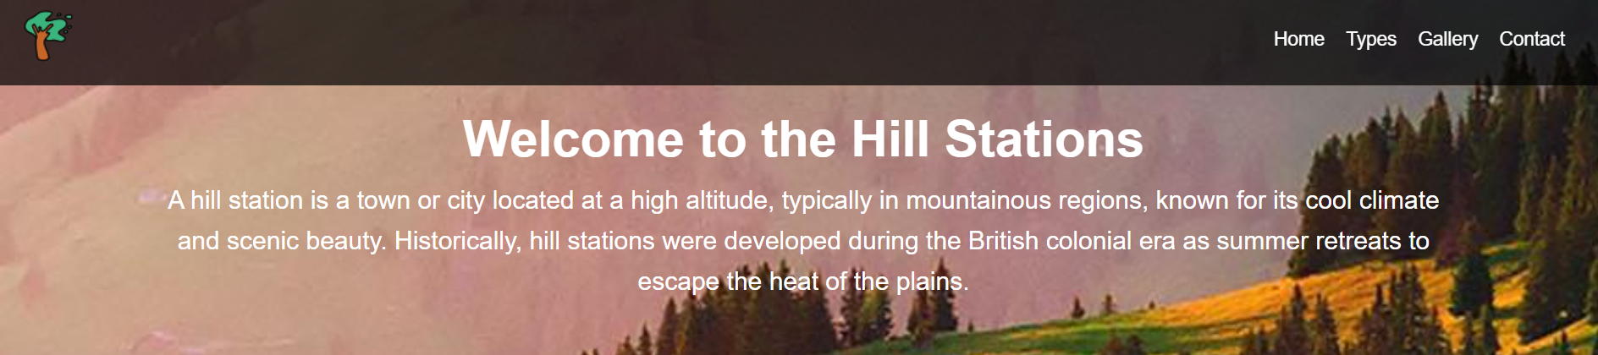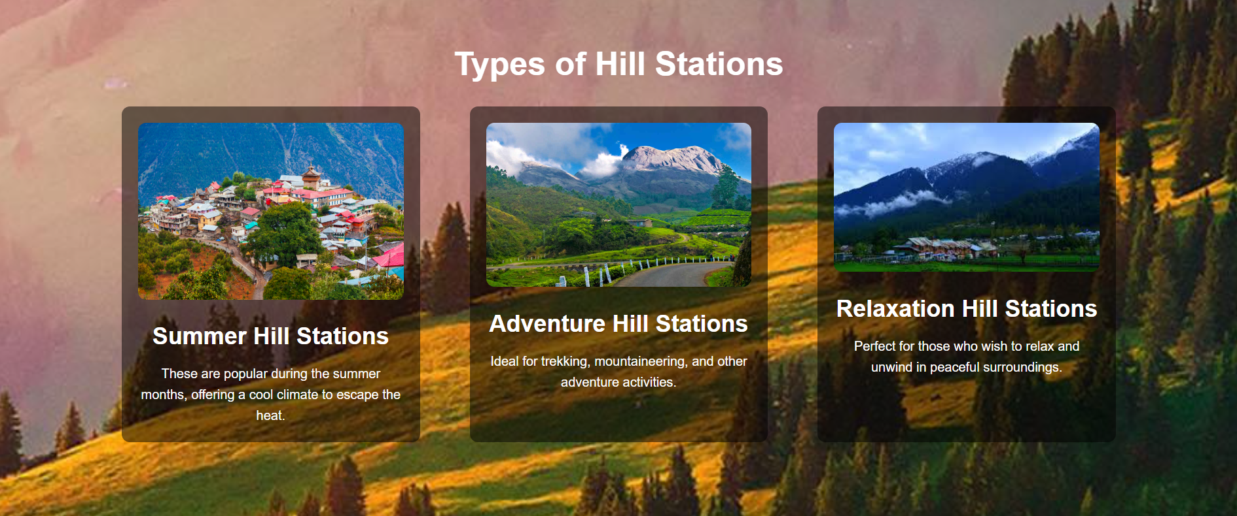

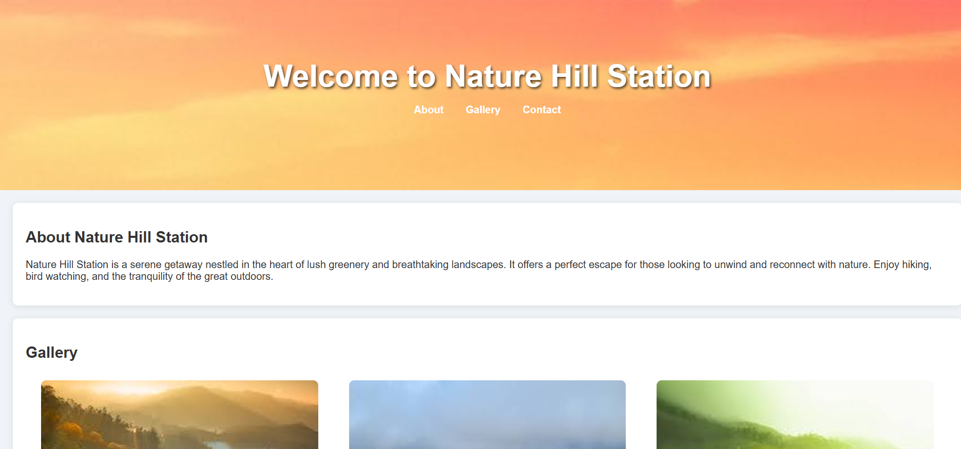

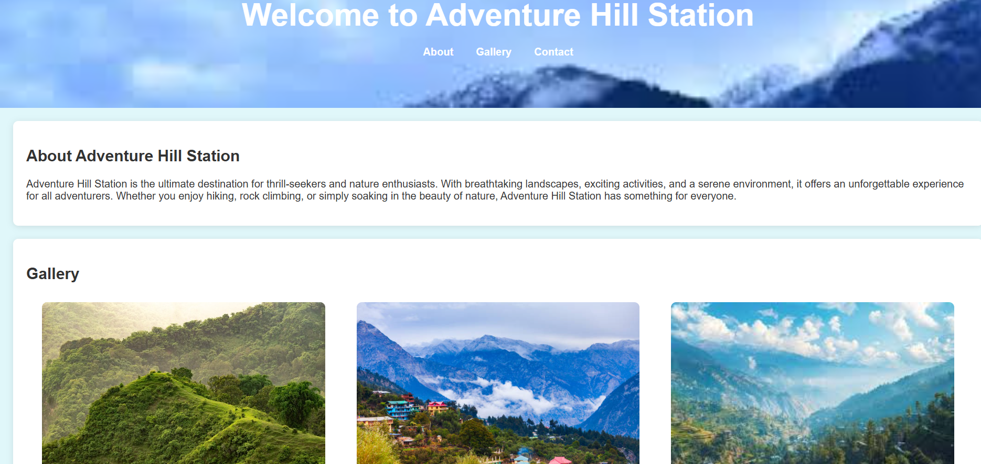

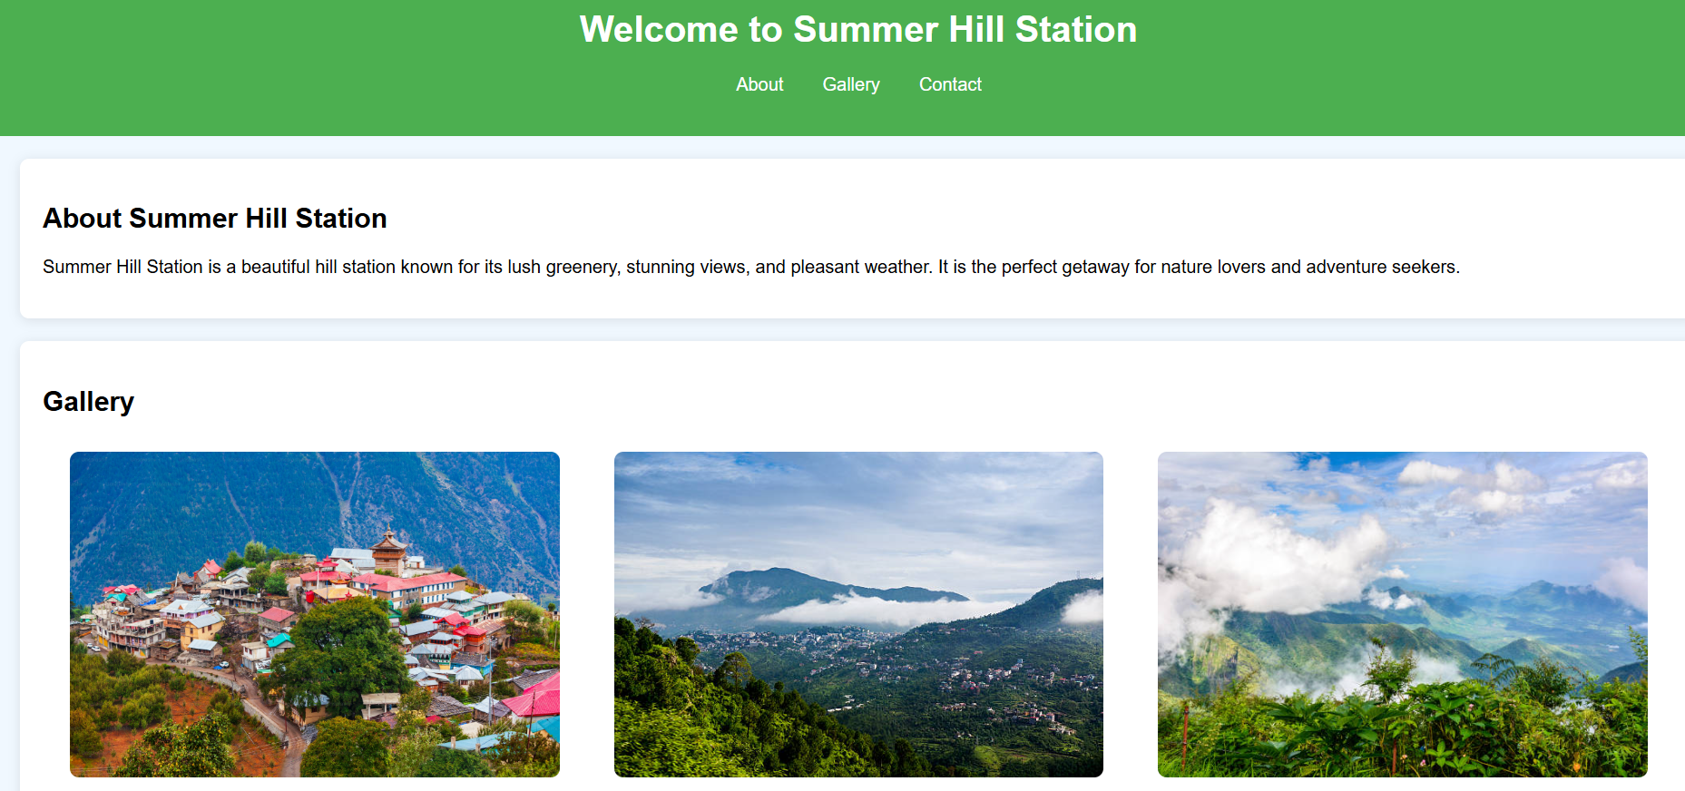

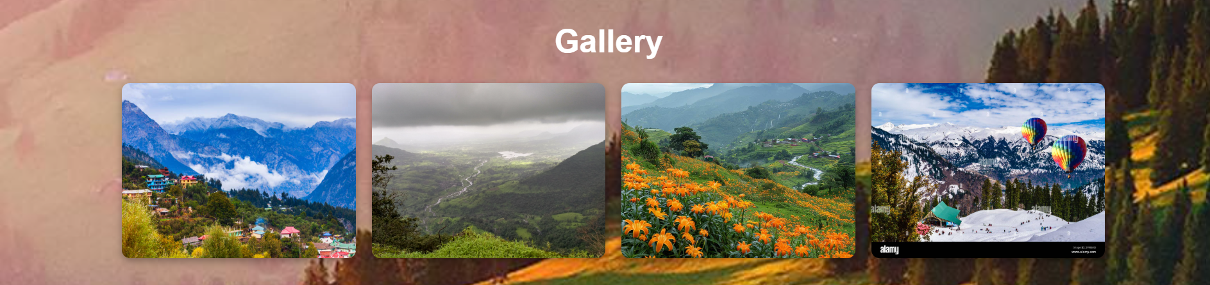

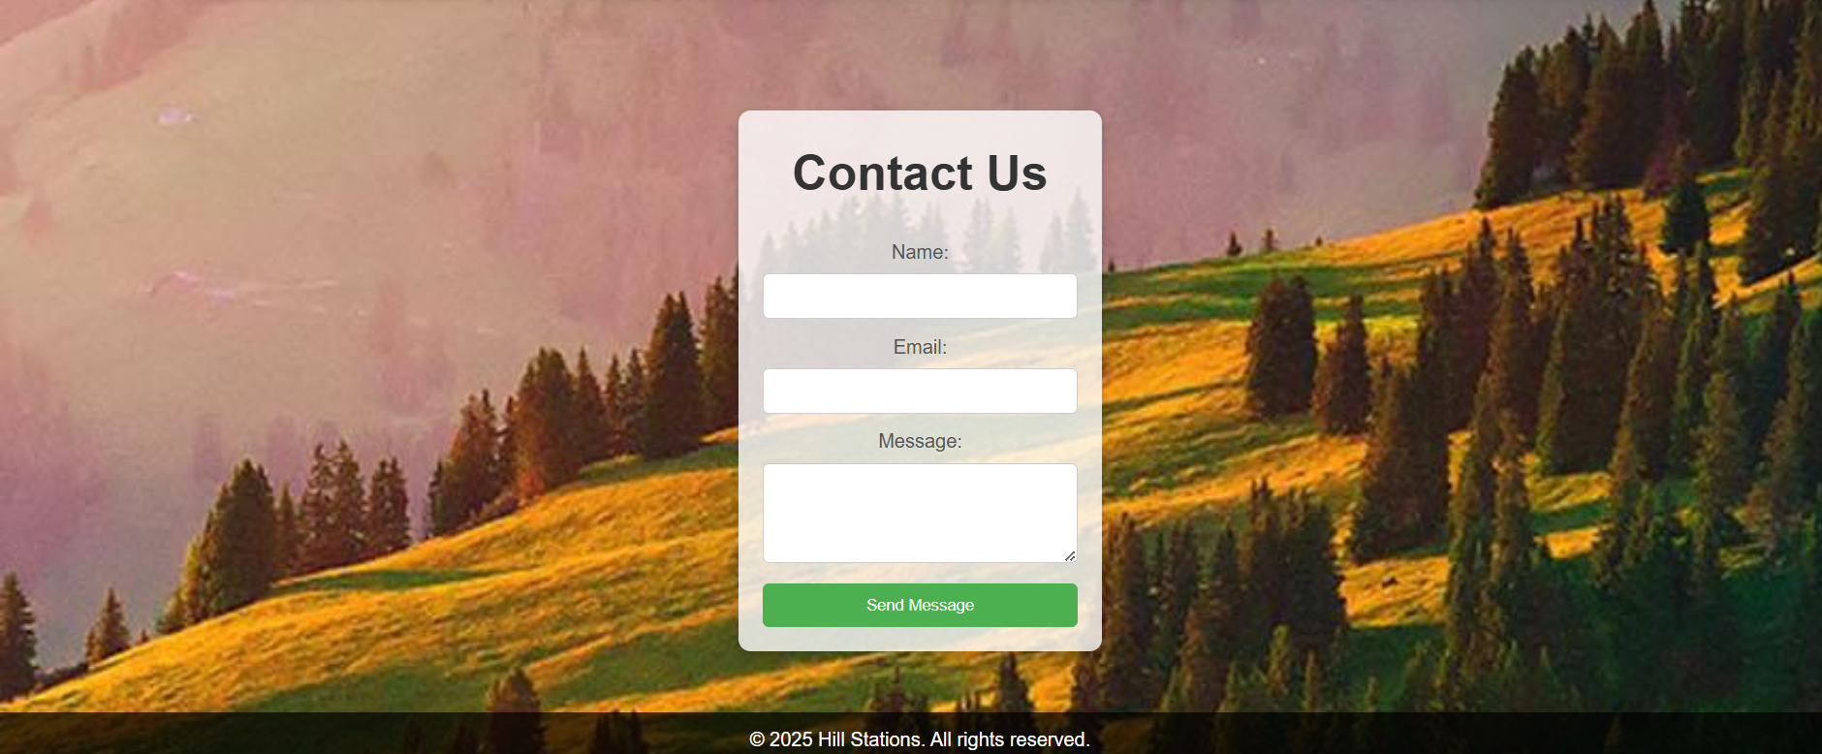

### CONCLUSION

In conclusion, hill stations offer a unique blend of natural beauty, cultural richness, and tranquility, making them ideal destinations for relaxation, adventure, and eco-tourism. Through this project, we have explored the various aspects of hill stations, including their geographical significance, historical development, tourism impact, and challenges faced by local communities. The development of hill stations requires a balanced approach that respects the environment, promotes sustainable tourism, and enhances local livelihoods.The project successfully achieved its objectives by:

1. **Natural Beauty and Attractions**: Hill stations offer breathtaking landscapes, unique flora and fauna, and serene environments, making them ideal for nature lovers and adventure enthusiasts..
2. **Tourism Potential**: Hill stations are major tourist destinations, contributing significantly to local economies by attracting visitors for leisure, adventure sports, and eco-tourism.Creating a database to store customer and product information.
3. **Historical and Cultural Importance**: Many hill stations have rich historical backgrounds, having served as colonial retreats, and continue to maintain their cultural significance in local traditions and architecture.
4. **Future Prospects**: With proper planning, hill stations can continue to thrive as sustainable tourism destinations, offering both economic opportunities and environmental preservation for future generations.

### REFERENCES

#### Online Services

* + - Black box
    - W3Schools
    - Chat GPT

#### Self made knowledge of

* + - HTML
    - CSS
  + Internet references(Google Chrome)
    - Doubts
    - References